**PROJECT DOCUMENTATION**

**PROJECT TITLE: RHYTHMIC TUNES-YOUR MELODIC COMPANON**

**Screenshots**

* **Home page:**

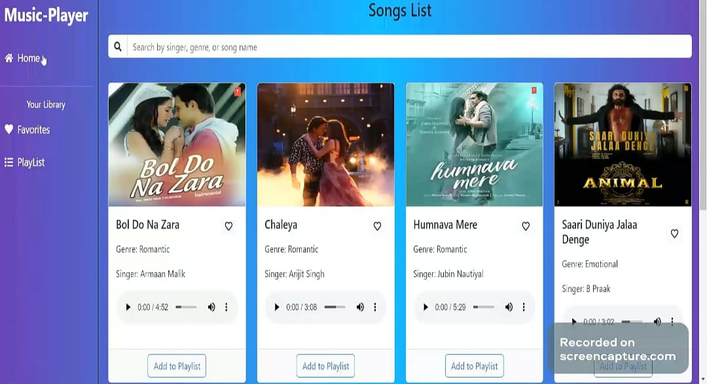

* **Playlist:**

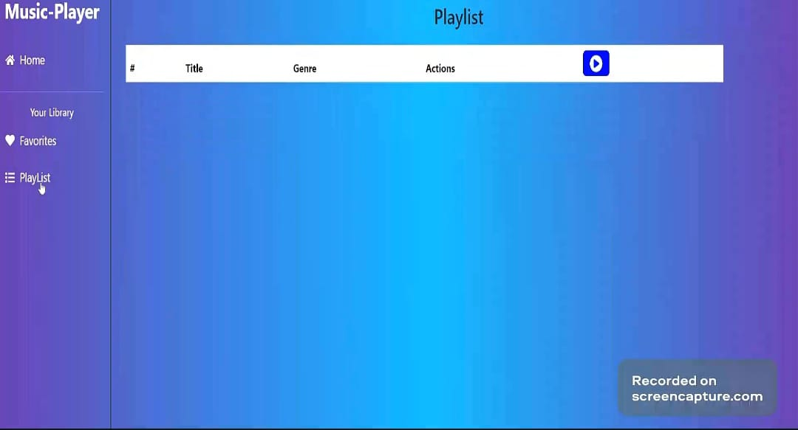

* **Songs List:**

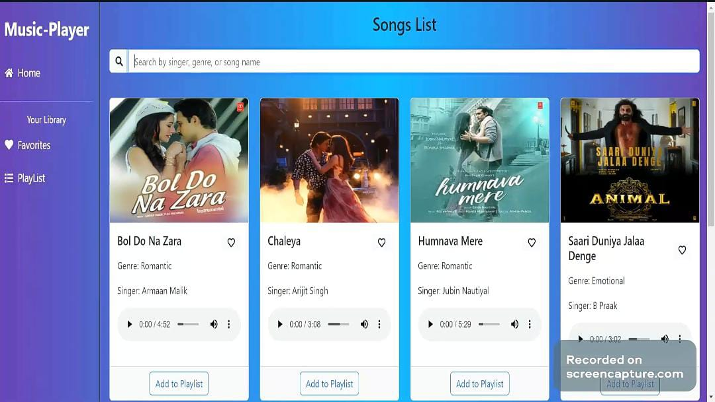

* **Select the song:**

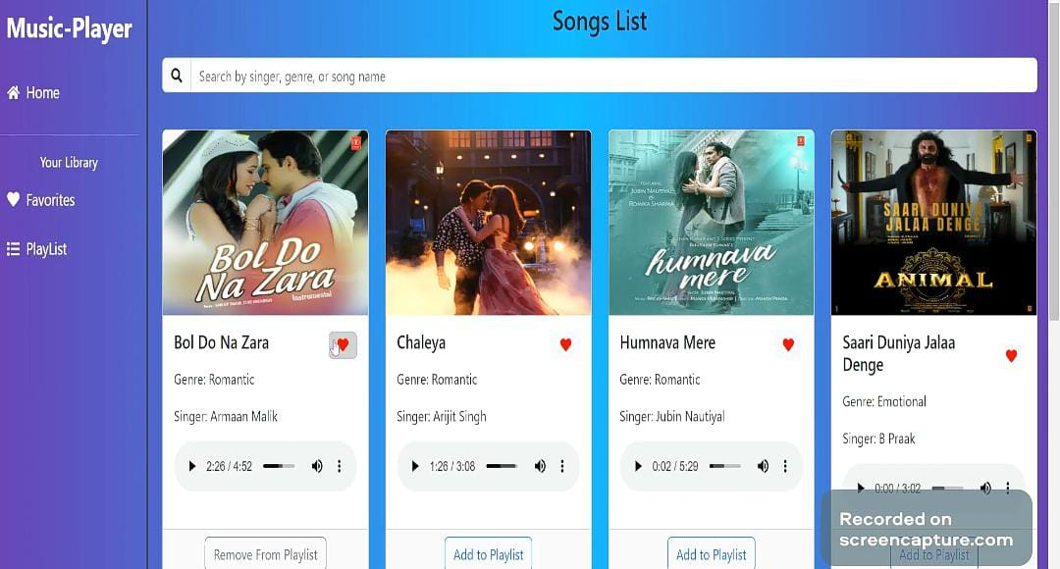

* **Added to Favorites List**:

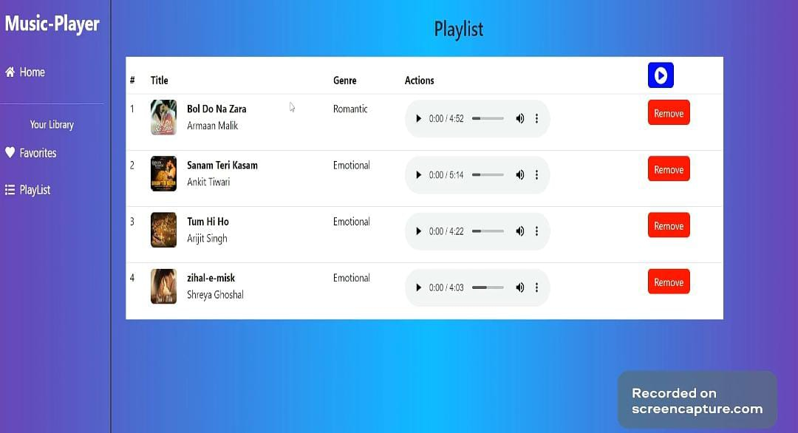

* **Favorites List:**

